Snake Body - power supply document.

Segment length is 90 mm including Universal Joint. Est total snake length is 1060 mm being 10 x segments (900mm) plus head (60mm) and tail (100mm) pieces.

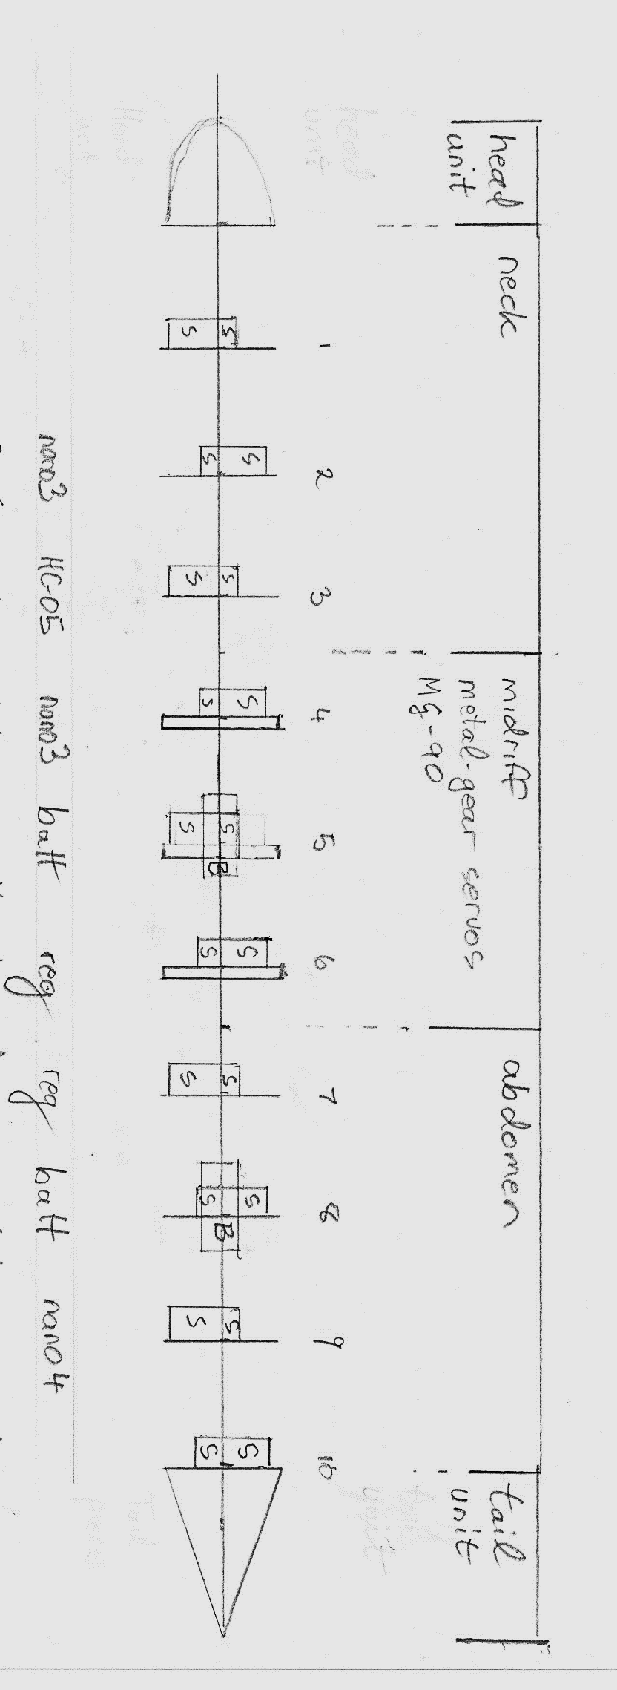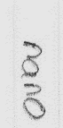

Batt

Batt

Reg01 and Reg02 are regulators providing 5.4 V output from 2S Lithium Ion Battery supply nominally 7.4V

Reg01 is mounted on Rib06 but it feeds power to Rib01 - Rib05.

Reg02 feeds Rib06 - Rib10

If we later feed power to the head computer then for load-sharing,   
line from Reg02 will extend to the head. Shown here as a dotted line.

Repeat of base page notes.

S = Servo. Horizontally-mounted servos alternate sides segment by segment.   
 to even-up weight distribution.  
 Midriff segments 4, 5, 6 have heavier duty Tower MG-90 metal gear servos.  
 Neck and Abdomen segments have Tower SG-90 plastic gear servos.

B=Battery Wild Scorpion 2S - 7.4V nominal - 500mAH - mounted into segments 4 and 8.  
Segments 4 and 8 have vertically mounted servos in the top half of the "rib" leaving bottom half clear  
to mount the battery.  
Power supply to segments 1-5 is separate to and independent of power supply to segments 6-10